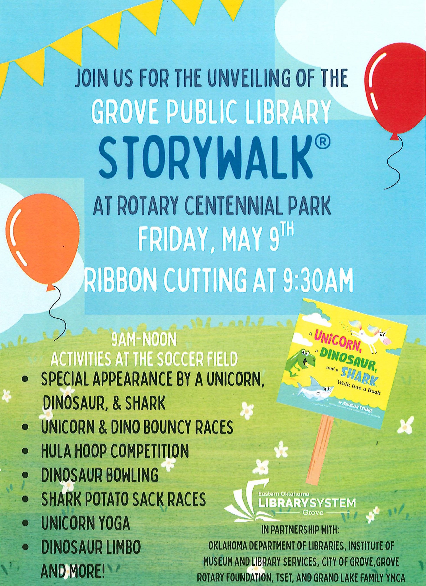THE UNVEILING OF THE

GROVE PUBLIC LIBRARY

# STORYHALK@

AT ROTARY CENTENNIAL PARK

TH